Drug discovery is the process through which potential new therapeutic entities are identified, using a combination of computational, experimental, translational, and clinical models. Drug discovery encompasses a variety of stages and procedures, from conception to approval.
What is Drug Discovery Process?
The drug discovery process is a very long process. Typically, screening for potentially active compounds is the first step in the early drug discovery process. Following their discovery, these substances are tested for safety and efficacy. They must have a therapeutic effect on the intended ailment.

Drug discovery process involves many different stages and series of action.
Typically it can divide into four stages which are-
- Early drug discovery
- Pre clinical phase
- Clinical phases
- Regulatory approval.

- Early drug discovery: Early drug discovery process which can involve many different actions and testing as well. This stage can be divided into these following sub processes –
Target identification and validation, high throughput screening and high content screening, hit identification, assay development, hit-to-Lead, lead generation, and in Vivo and in vitro assays
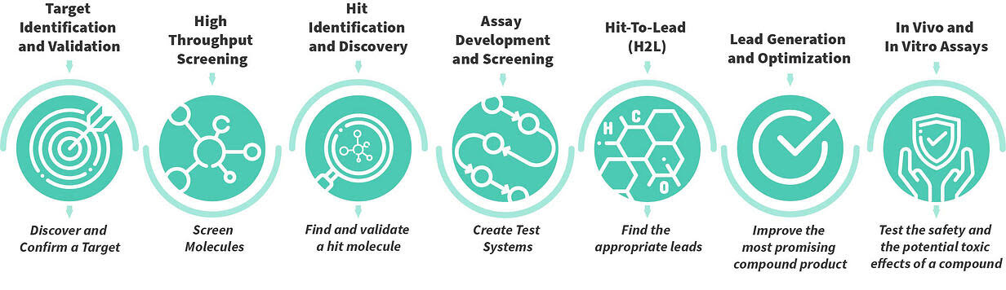
.

- Target identification and validation: The entire process of finding new drugs begins with identification and validation of targets. Normal targets for treatments are naturally occurring cellular or modular components that seems to play a significant role in pathogenicity or disease development. When the target is identified , researchers confirm a targets eligibility for drug development before going through the screening procedure to find the hits.
- High throughput screening and high content screening: It is one of the most important steps towards discovering a drug. The initial point can find out by screening a large number of molecules that can interact with a prospective target after it has been identified and validated.
- Hit identification and screening: There are various types of methods can use to identify a hit molecule. Some examples can be used to discover hits such as high content screening, structure based screening, fragment based screening etc.
- Assay development and Screening:
- Hit -to- Lead : It is also one of the most important steps in early drug discovery. It has moto , is to find out the appropriate leads to move along the pathway to a final clinically active drug. It is mentioned that, lead properties must be adequate to examine their efficacy in any in Vivo models.
- Lead generation and optimization: The lead optimization procedure will start as soon as the lead is produced during the Hit-To-Lead process. The most promising chemical products are improved through lead optimization to boost efficacy, decrease toxicity, or increase absorption.
- In Vivo and in vitro assay: It is used to test the safety and the potential toxic effects of a compound by using alternative models, animal models like as cell cultures etc.

- Pre clinical phases: The second step is the Pre-Clinical Phase, one of the four main stages of the drug discovery process. The compounds discovered during Early Drug Discovery are extensively investigated in a lab setting as well as using animal or alternative models throughout the Pre-Clinical Phase. Prior to Human Clinical Trials starting, there must be sufficient proof of safety and efficacy. Once this is established, it is also helpful to determine the right doses to test in humans. It must be guaranteed that the new chemical will be accessible in appropriate amounts during the clinical investigations before the Clinical Trials begin. Previously, only tiny quantities were needed, thus manufacturing now needs to be adjusted to the vastly increased demand in the Clinical phases.
- Clinical phases: Clinical trials has four phases. They are Phase I, Phase ll, phase lll, phase 4

